For deployment CI and CD we will use Jenkins and code is maintained under Azure DevOps repositories and infra deployment is done by terraform and ansible via scripts and application deployment is done by helm under the Kubernetes

We have two project

European project: EU27 and for North America we are calling it as Yellow stone (YS) and we are building the same infra in Yellow stone

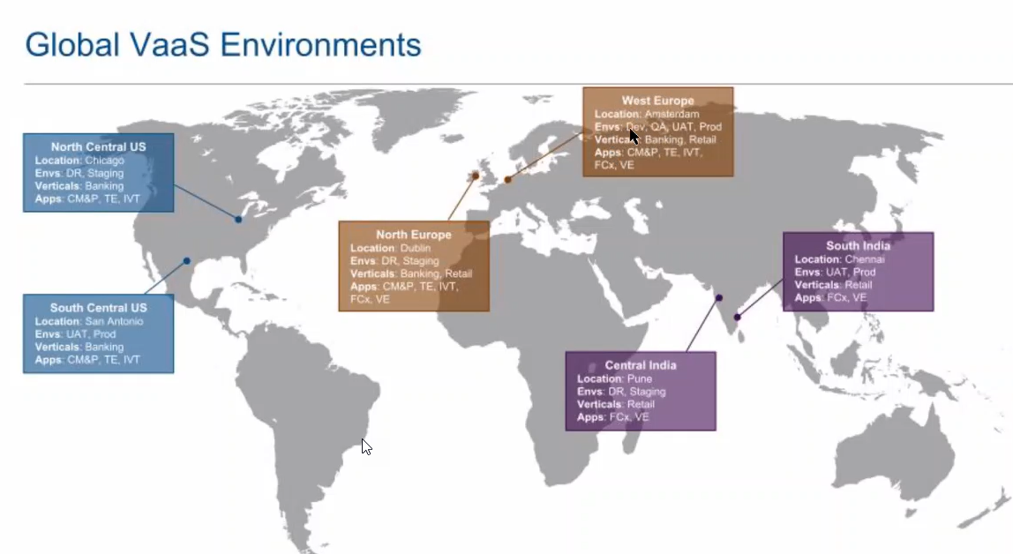

Apps: TE – Transaction as service (we are mainly dealing this)

We are having two tenants one is for service test end and other one is service.

Service is basically the production and service – test is for the nonprod

We have orange, green, and purple boxes and we are responsible for the boxes

In Non prod we have many verticals that means as part of EU 27 project we are maintaining the banking vertical likewise there is another vertical called retail and the infrastructure is same for retail and banking for nonprod mentioned as cmn

But in higher environment like staging and production there are having their own infrastructure expect the global service. Global will be common throughout the environment and for project (retail and banking)

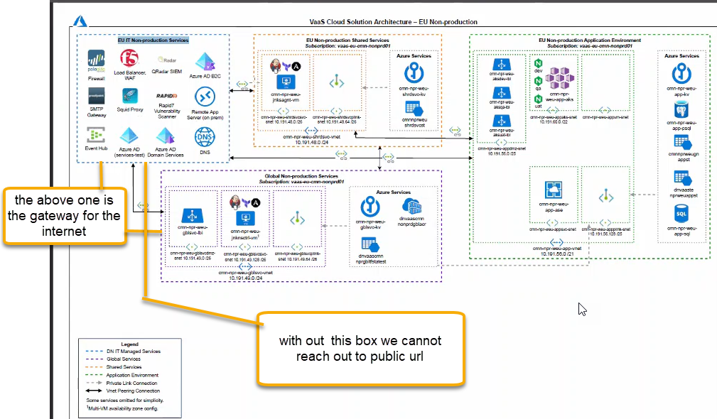

In the global we are having Jenkins master, necessary storage account, private end point to the docker container registry. We are not building any docker images and we are consumer of docker images. We pull the docker images into Azure container registry

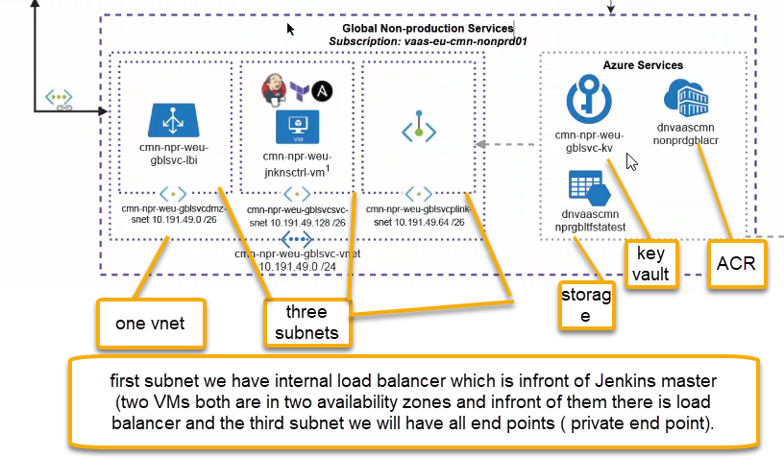

If you need to connect to ACR from here it will connect connection from this subnet ( private end point)

Cloud shared project > Repos > Branches > Global Infra

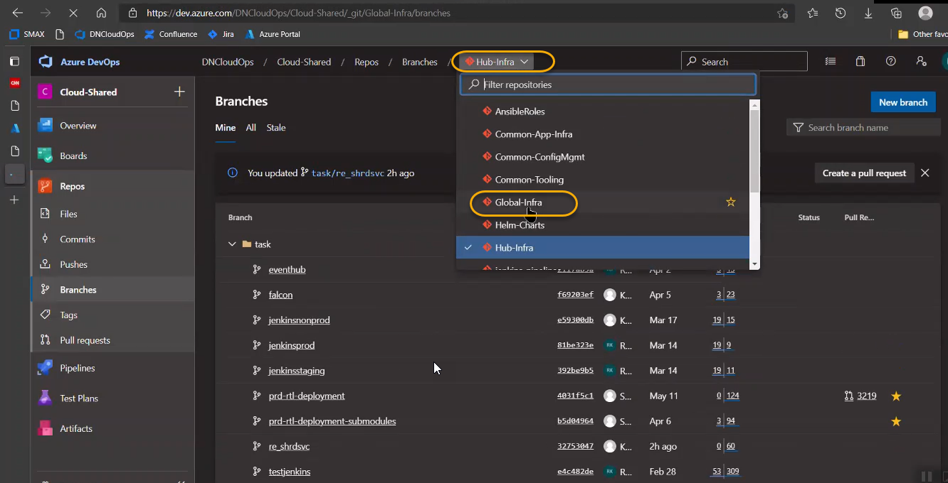

Under the global infra there are two branches nonprod and staging and staging is equal to master

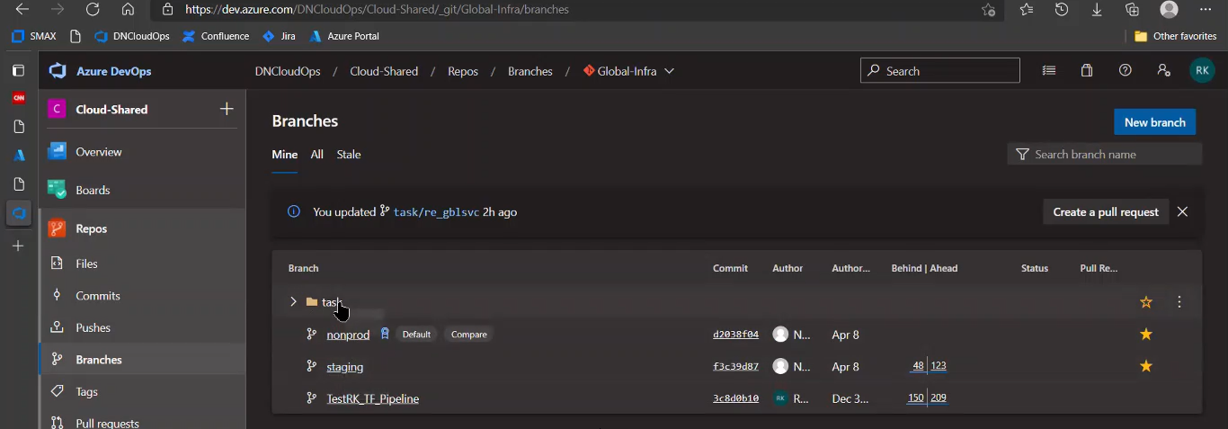

Click on re_gblsvc

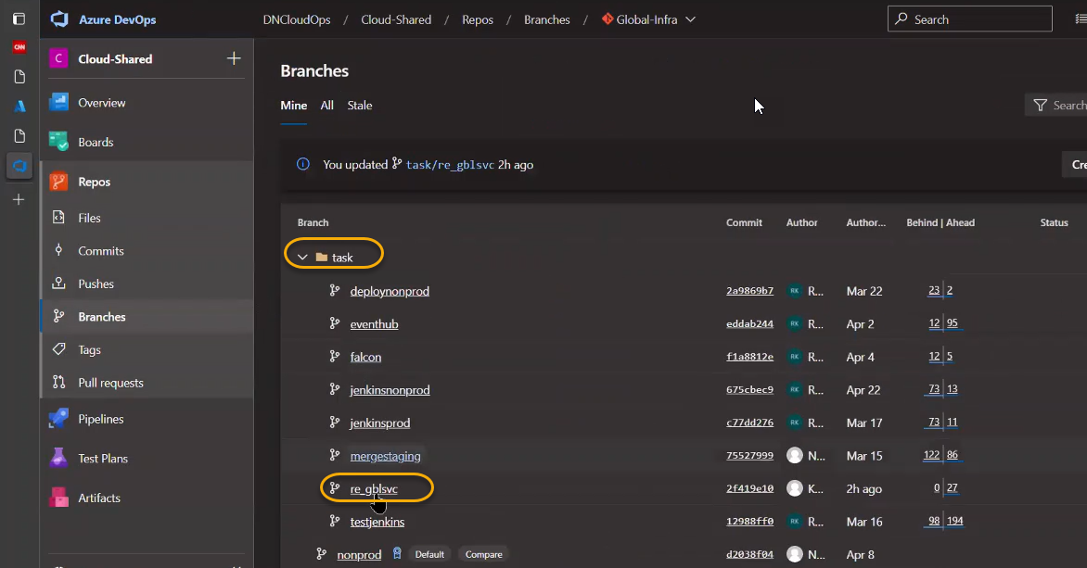

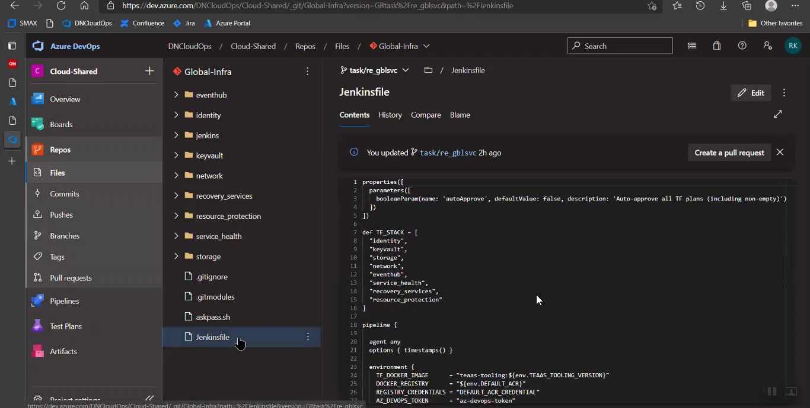

Jenkins file is the triggering point . and under the jenkins we have 4 folders

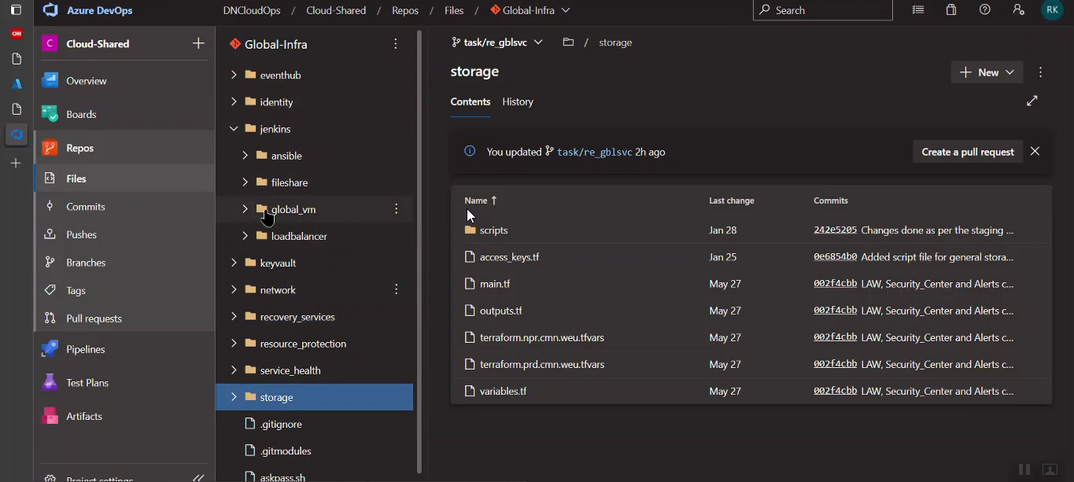

Ansible will configure the VM. Any necessary tools and configurations required for VM will be installed via ansible.

Network, key vault, storage, and Jenkins are the main ones and remaining ones for monitor purpose

In order to distribute the loads of Jenkins master we are spinning to the Jenkins Agent. From master it will handover the job to particular vertical special Jenkin agent

For production Jenkins master if you want to deploy in banking it will handover upper to Jenkins agent

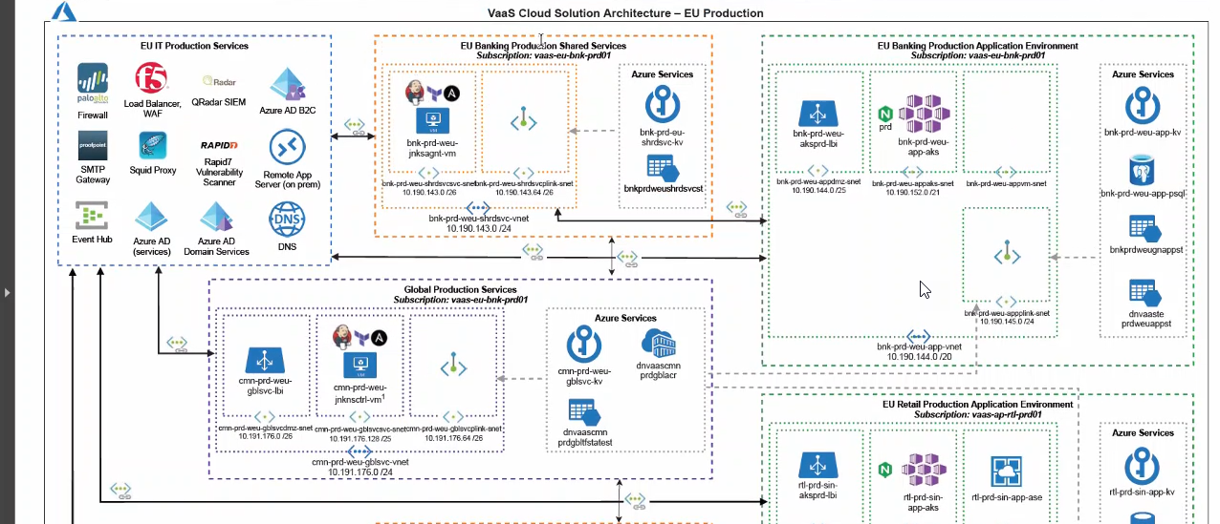

And if you want to do deployment of retail it will handover to below agent ( retail agent)

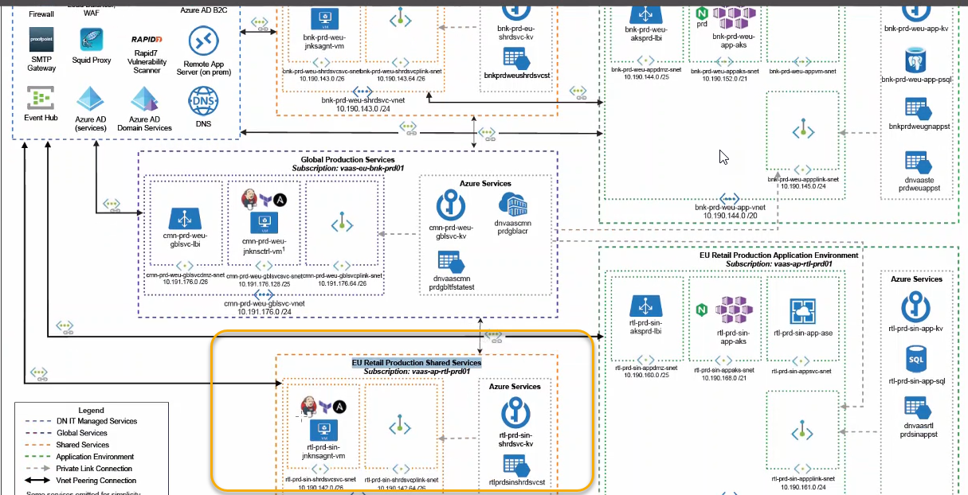

The Jenkins master acts to schedule the jobs and assign slaves and send builds to slaves to execute the jobs. It will also monitor the slave state (offline or online) and getting back the build result responses from slaves and the display build results on the console output.

A "master" operating by itself is the basic installation of Jenkins and in this configuration the master handles all tasks for your build system. ... An agent is a computer that is set up to offload build projects from the master and once setup this distribution of tasks is automatic.

In non-prod we are sharing the infra we don’t have separate agent for the data ( non-prod -cmn)

Whereas in the production we have banking and retail (bnk and rtl) which is vertical is going to which resource

For shared infra we can refer the code in Hub-infra

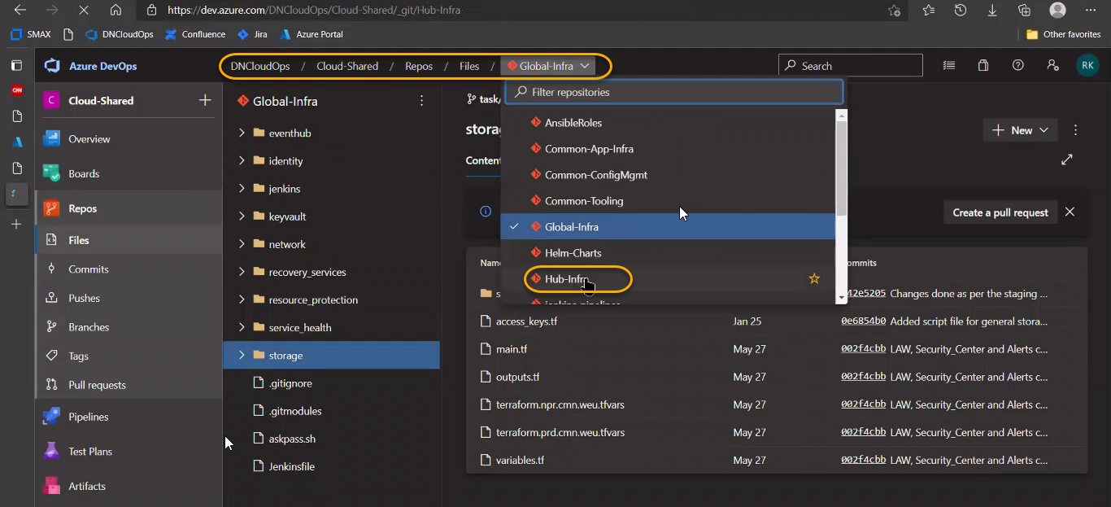

The order to deploy (in Hub Infra/shared infra) is key vault > storage > network > Jenkins > configuration of Jenkins VM via Ansible. However in the below the order is wrong

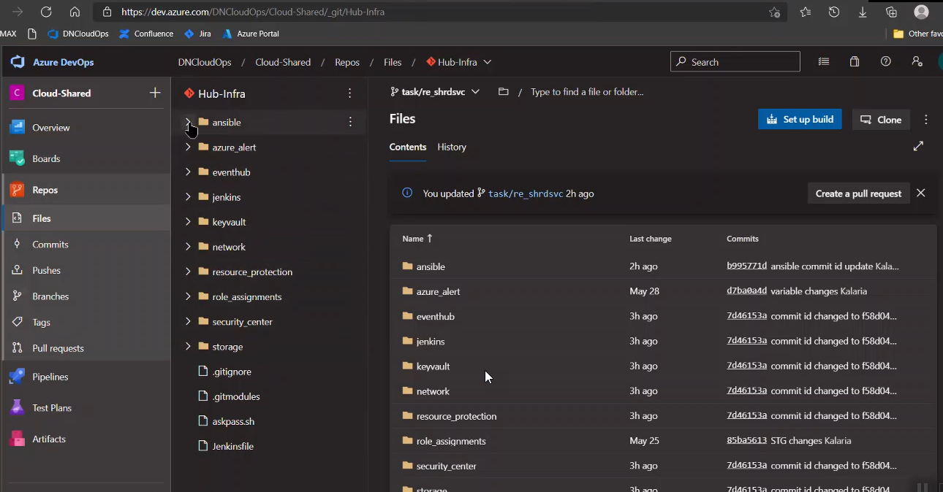

The jenkins Agent will not install the Jenkins it will spin up the VM with Docker and couple of additional tools

The purple box and orange box is purely for Jenkins CI and CD and the main box is greenbox

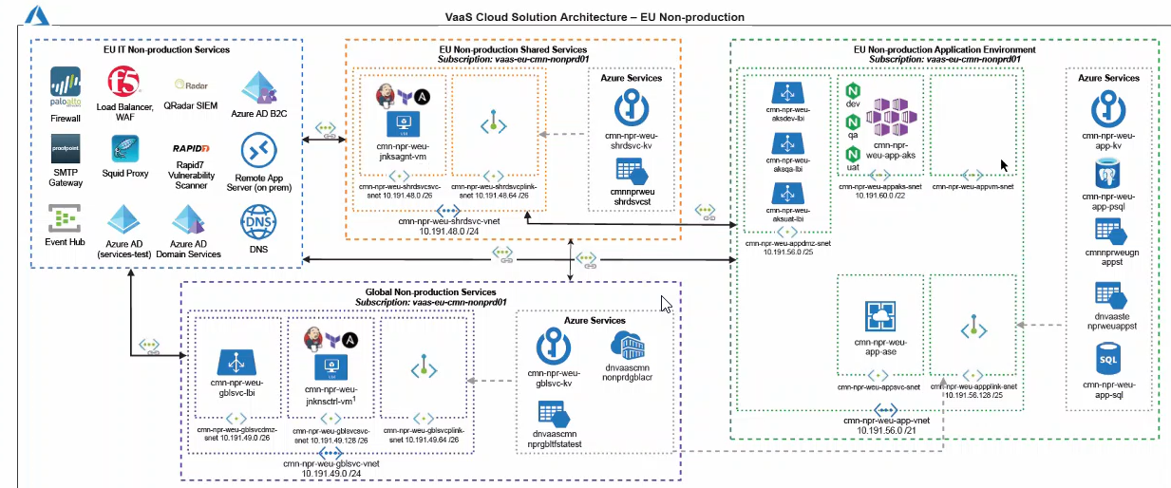

Git bash >

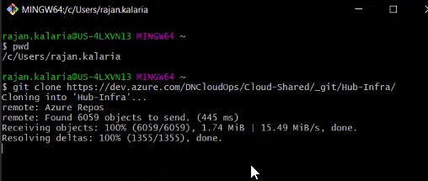

If you are unable to clone due to password issues or not set

Generate the token from personal access token

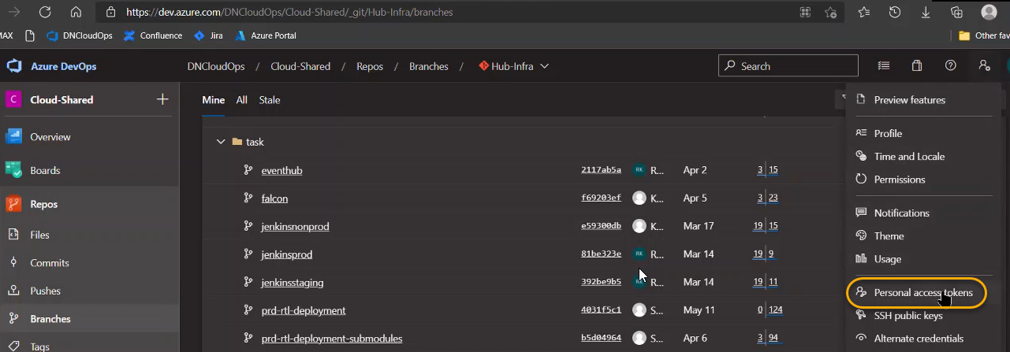

If you generate the token then that token we can give in gitbash

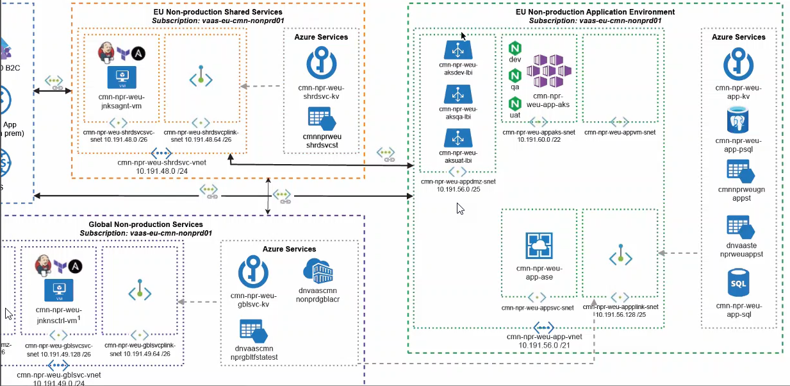

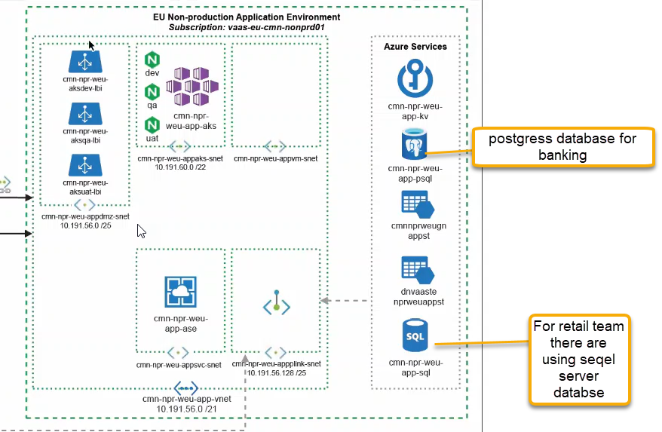

We are ONLY using load balancer, container(dev, qa and uat) and Private End Point

Go to common App infra in Azure repos

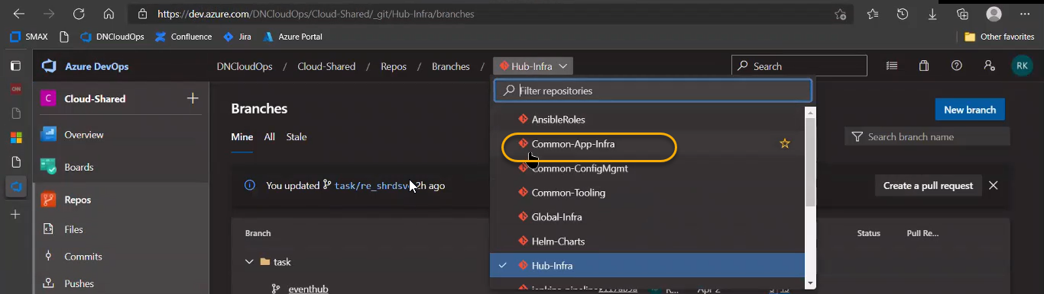

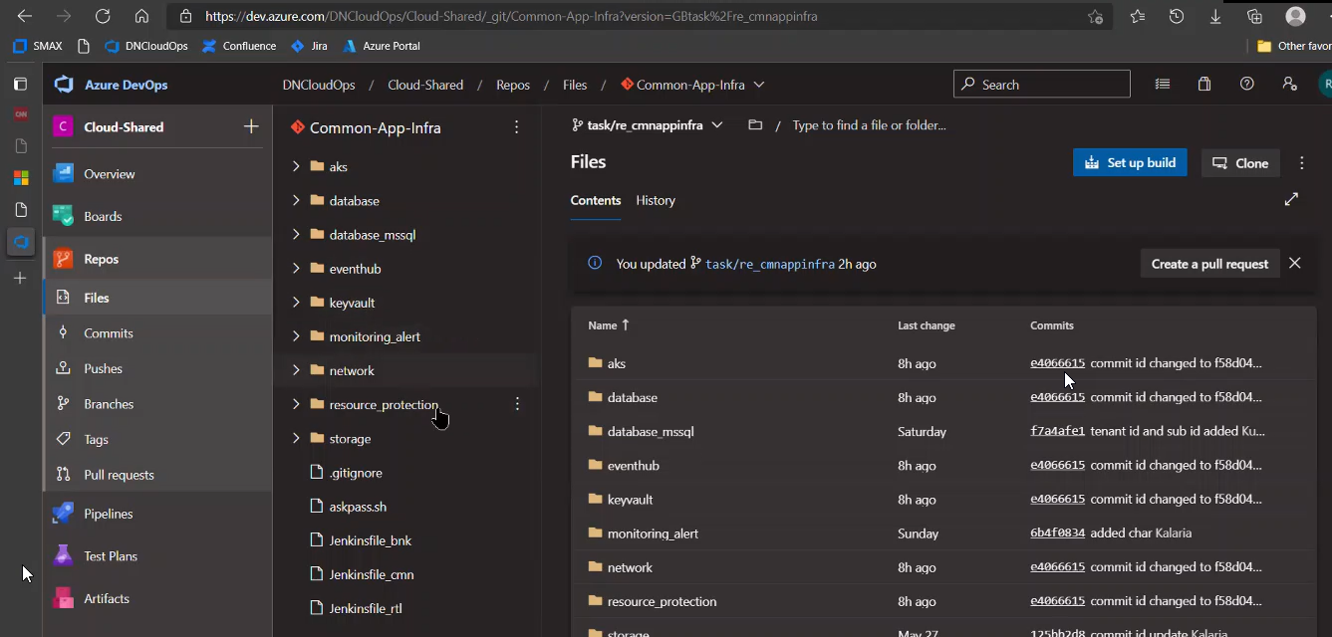

database_mssql is maintained by retail

Apart from three repos we have common called TEass which is application specific things

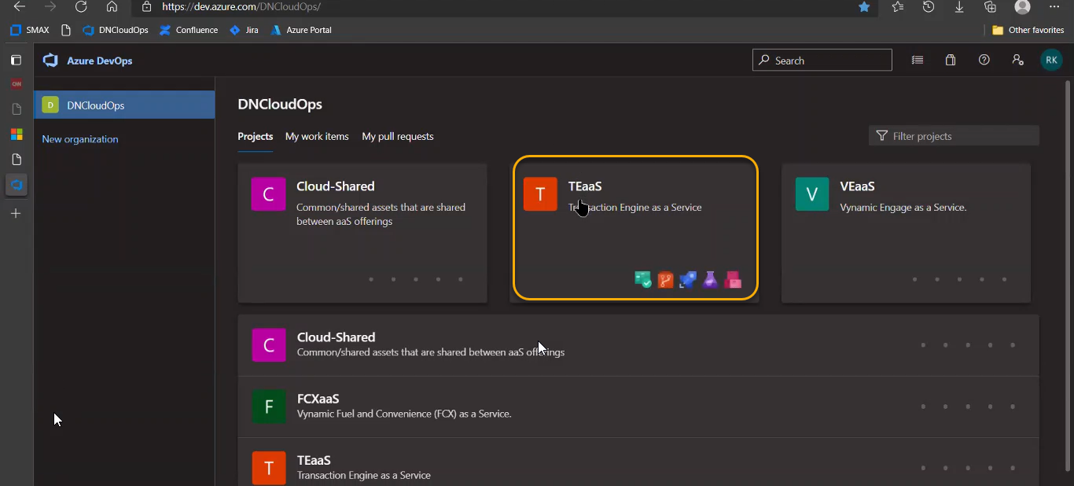

Cloud shared is commonly shared infra and TEaas we have application separate infra

Go to TEaas > Repos > Branches

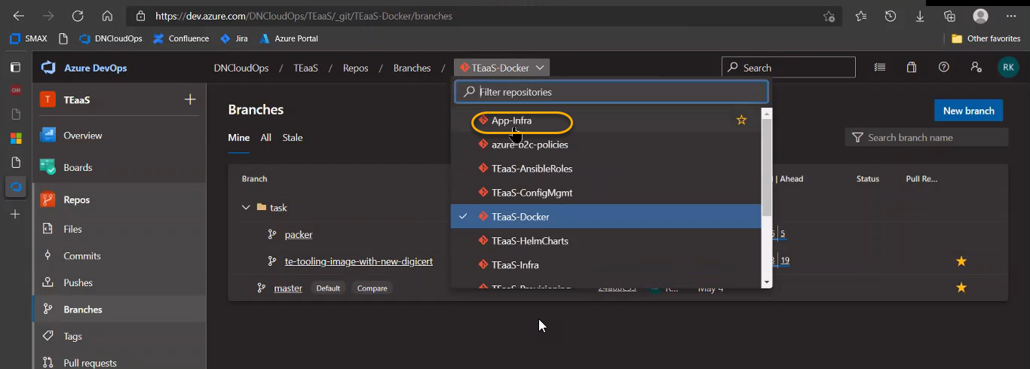

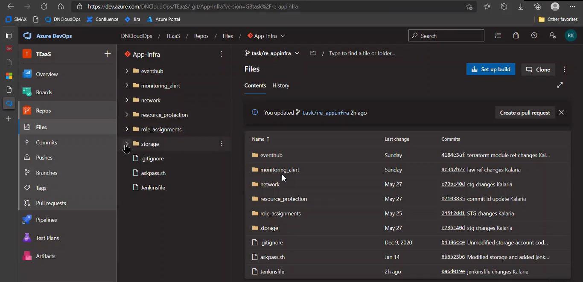

Storage will have the couple of storage account and will link to log analytics workspace and network will link in common infra.

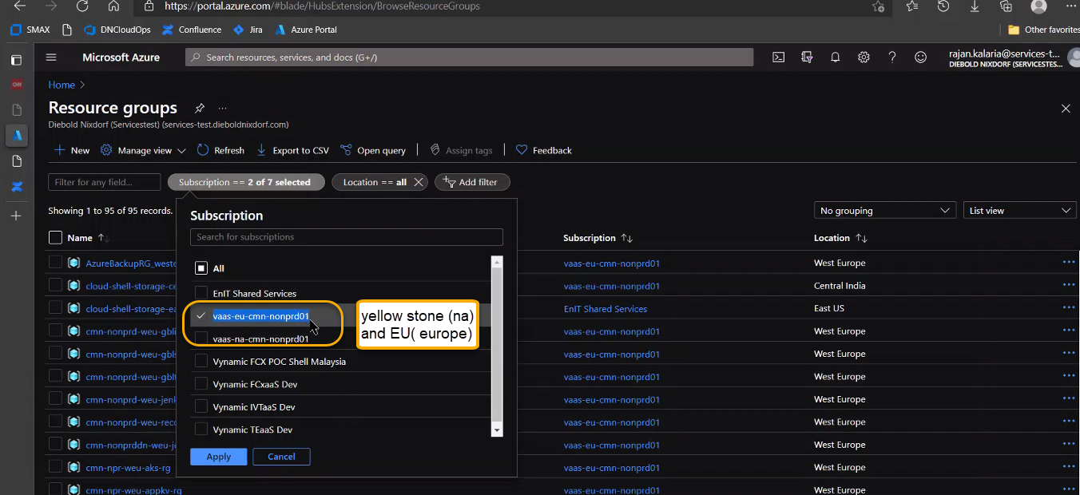

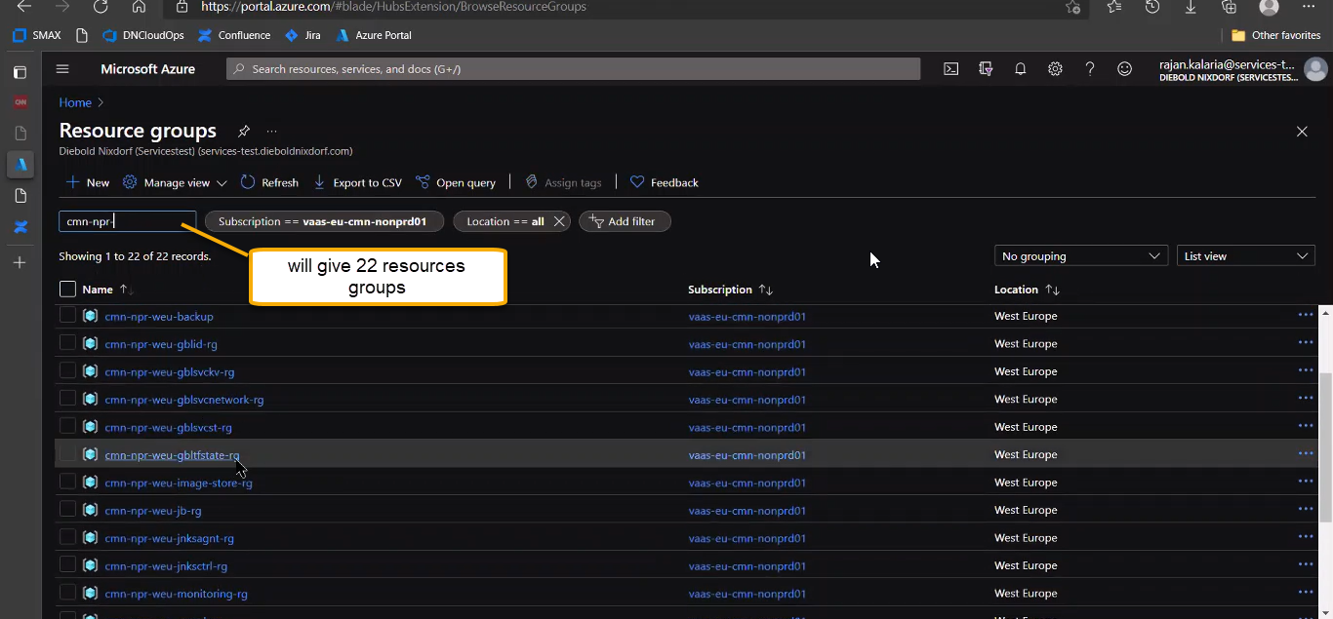

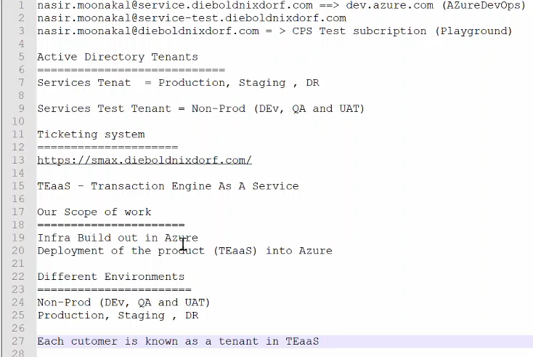

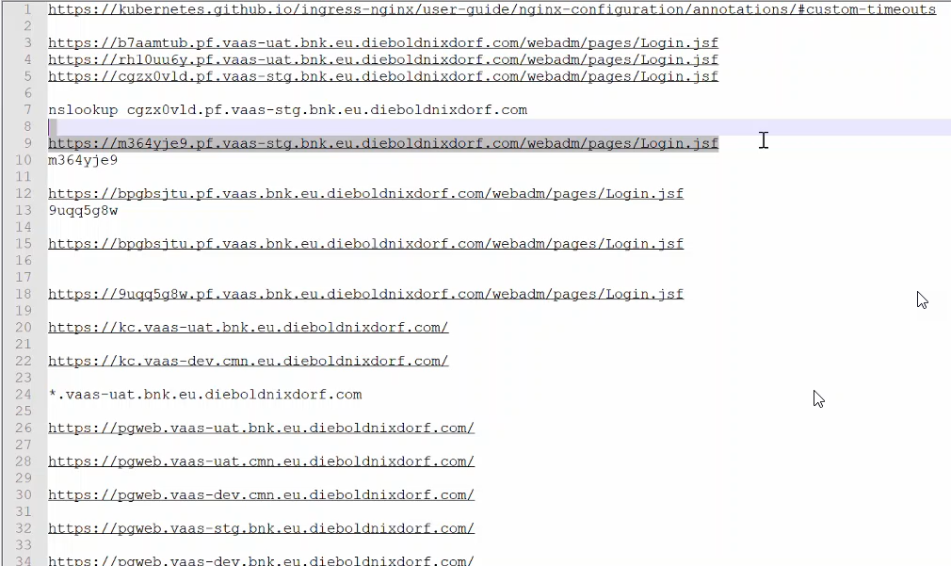

Cgzx0vld is tenant Id with reference to 5th line and with respect to above screenshot

